

**SCHOOL OF INFORMATION SCIENCE**

**COLLEGE OF COMPUTING, INFORMATICS AND MATHEMATICS**

**UNIVERSITI TEKNOLOGI MARA (UiTM), MERBOK, KEDAH.**

**DIPLOMA IN INFORMATIC LIBRARY (CDIM144)**

**PROGRAMMING FOR LIBRARIES (IML208)**

**GROUP PROJECT:**

**HOTEL ROOM BOOKING SYSTEM**

**PREPARED BY**

|  |  |
| --- | --- |
| **ANIS SUFFIYA HISHAM** | **(2022861418)** |
| **IMAN AMILA REDZA BIN NABIL KHAIRI** | **(2022411538)** |
| **NOR KAMILLAH BINTI MOHD RANI** | **(2022827148)** |
| **NUR ANIS AYUNI BINTI IDHAM** | **(2022895228)** |

**GROUP**

**KCDIM1443D**

**PREPARED FOR**

**SIR MOHD FIRDAUS BIN MOHD HELMI**

**SUBMISSION DATE**

**17TH JANUARY 2024**

**ACKNOWLEDGEMENT**

Alhamdulillah, praise be to Allah Almighty, the Beneficial and the Merciful and peace be upon Him of the glorious visit of the prophet Muhammad SAW. Thanks, giving to the Divine wish for His grace, we managed to finish our group assignment.

The sources and outcome of this assignment required a lot of guidance and assistance from many people, and we are extremely fortunate to have gotten this all along with the completion of our assignment work. Special gratitude to our project lecturer, SIR MOHD FIRDAUS BIN MOHD HELMI, as our mentor as he already taught us more than we could give him credit for here and helped us to coordinate our group project on the Hotel Room Booking System, especially in writing assignment.

Furthermore, we would also like to take this opportunity to thank our friends and classmates, without them this assignment could not completed in a short duration.

Most importantly, nobody has been more important to us in pursuit of this assignment than our family members. We would like to thank our parents, whose love and guidance are with us whenever we pursue. They are the role models.

Lastly, we want to thank ourselves for not giving up on doing this assignment.

We are thankful to them that mentioned.

**TABLE OF CONTENT**

ACKNOWLEDGMENT……………………………………………………………………………………ii

TABLE OF CONTENT…………………………………………………………………………………...iii

1.0 PROJECT NAME…………………………………………………………………………………….1

2.0 PROBLEM STATEMENT……………………………………………………………………………1

3.0 BACKGROUND OF THE SYSTEM…………………………………………………………..…….2

4.0 FLOWCHART ………………………………………………………………………………………...3

5.0 PSEUDOCODE………………………………………………………………………..…………..…4

6.0 STRENGTH……………………………………………………………………………………….…..5

7.0 KAIZEN ………………………………………………………………………………….…………….5

8.0 PYTHON PROJECT DETAILS………………………………………………………...……………6

**1.0 Project Name:** Hotel Room Booking

**2.0 Problem Statement:**

1. Manual record-keeping takes a lot of time and is prone to mistakes, which lowers sales and decreases customer satisfaction.

2. The conventional hotel management systems are antiquated and incapable of adapting to the hotel industry's shifting demands.

3. Managers are unable to optimize their operations and make well-informed decisions due to the absence of real-time data analytics and reporting in hotel management systems.

**3.0 SYSTEM BACKGROUND**

The Hotel Room Booking System presents a transformative solution to the inherent challenges prevalent in traditional hotel management practices. The persistent reliance on manual record-keeping has long been a bottleneck, consuming excessive time and introducing errors that impede operational efficiency and diminish customer satisfaction. Moreover, the outdated nature of conventional hotel management systems compounds these issues, lacking the adaptability needed to meet the evolving demands of the dynamic hospitality industry. This system stands as a beacon of innovation, aiming to streamline operations and enhance customer experience by introducing user-friendly interfaces, a simple graphical user interface (GUI), and a direct, efficient approach to hotel management tasks.

In its pursuit of continuous improvement, the Hotel Room Booking System incorporates robust strategies. The implementation of an effective hotel management system automates procedures, ensuring accuracy, reducing error rates, and providing real-time data reporting and analysis. Leveraging cloud-based services adds a layer of scalability and adaptability, facilitating swift upgrades and customization. To further elevate the guest experience, the system envisions the creation of a mobile app for visitors, enabling them to manage reservations and access services seamlessly while on the move. The comprehensive functionality of the system includes data creation, reading, updating, and deletion, along with numeric functions for efficient calculations. Embracing various data types and a structured formatting approach, the system ensures not only operational efficiency but also a foundation for future enhancements. In essence, the Hotel Room Booking System marks a pivotal shift toward a technologically advanced and customer-centric paradigm in the realm of hotel management.

**4.0 FLOWCHART**

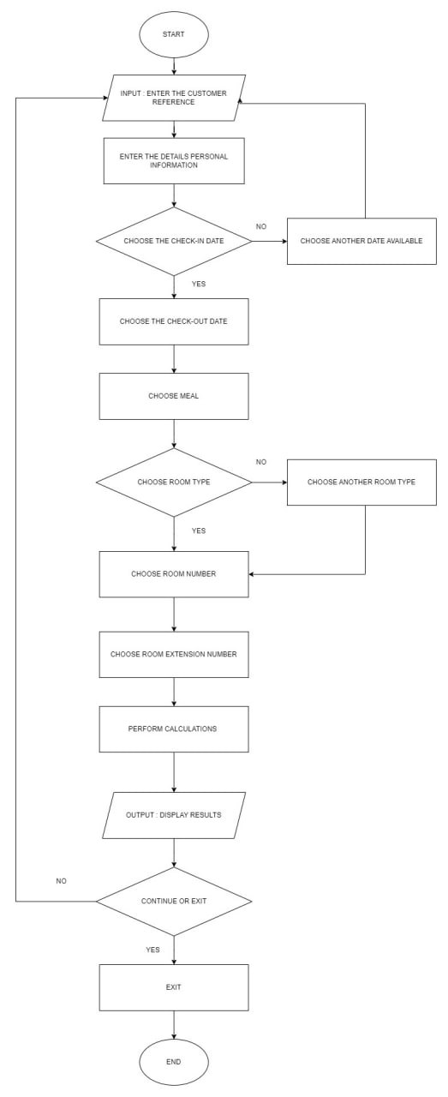

Figure 1: Hotel Booking System Flowchart

**5.0 PSEUDOCODE**

Begin

while (user wants to continue) {

display "Welcome to the Hotel Reservation System!"

display "-------------------------------------"

ask for customer reference number

read customer_reference

ask for personal information details

read personal_information

ask for check-in date

read check_in_date

while (check-in date is not available) {

display "Sorry, that date is not available. Please choose another date."

ask for check-in date again

read check_in_date }

ask for check-out date

read check_out_date

while (check-out date is not available) {

display "Sorry, that date is not available. Please choose another date.

**6.0 STRENGTH**

1. User friendly
2. Simple GUI
3. Straight to the point

**7.0 KAIZEN**

1. Putting an effective hotel management system in place: A contemporary hotel management system may automate procedures, improve operations, and offer real-time data reporting and analysis. This can enhance productivity, lower mistake rates, and enhance the general client experience.

2. Using cloud-based services: Cloud-based services provide hotel management systems with a scalable and adaptable architecture that makes upgrades, customization, and deployment quick and simple.

3. Creating a mobile app for visitors: Visitors may manage their reservations, make payments, and access other services while on the road with the help of a mobile app, which can offer real-time information and services. This may increase patron loyalty and satisfaction.

**8.0 PYTHON**

**File Name**: HotelRoomBooking.py

**GUI**: Yes

Figure 2. Screenshot of Login Interface

Figure 3: Screenshot of Hotel Room Booking Interface

**Result:**

Figure 4: Result for Hotel Room Booking

**Prompt Data:**

1. Customer References
2. First Name
3. Surname
4. Address
5. Postcode
6. Mobile
7. Email
8. State
9. Type of ID
10. Gender
11. Check-In Date
12. Check-Out Date
13. Meal
14. Room Type
15. Room No
16. Room Ext. No

**List All Functions:**

1. Create data:

Create the data by entering the information

1. Read data:

Can read the data history on the right frame

1. Update data:

Update data by editing on the right frame directly

1. Delete data:

Click “Clear” to delete data in the left frame and click Delete to delete the existing data.

1. Numeric Function:

Use “*”, “%”, “+”, and “==” function to calculate Tax and Total

1. Button:

Using buttons for “Total”, “Receipt”, “Clear”, “Delete” and “Exit”

1. String
2. Text Variable
3. Float
4. Entry Data
5. Horizontal Tab Character (\t)

**Conditional Statement:** Yes

Figure 5: Screenshot of Conditional Statement being used